Appendix D- Christmas trees

Dawley House

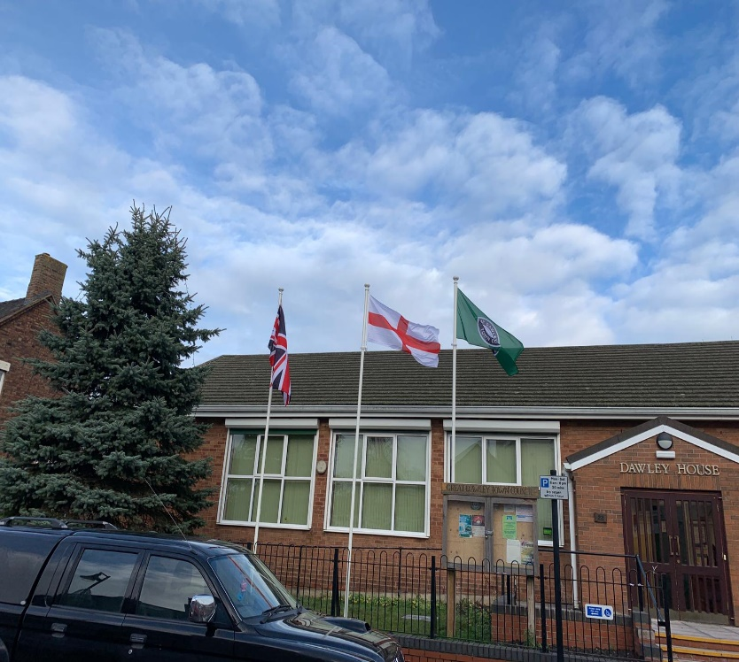

Malinslee Centre (has its own electric supply box separate to the Christmas displays)

