NOTICE
The Town Council’s
Executive Committee Meeting
to be held on
Monday 8th July 2024
The Public and Press are cordially invited to attend.
To transact the business set out below.
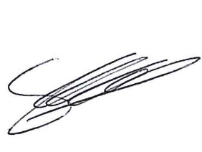
Signed Clerk of the Council

Date : 3rd July 2024

AGENDA

Chair’s Welcome

Apologies for Absence and Reasons
.
Code of Conduct

Public Session

Minutes

Grants

Finance
Clerks Report

Exclusion of Press and Public

Dawley Social Club

Councillor co-Option

Date of Next Meeting

