NOTICE
The Town Council’s
Executive Committee Meeting
to be held on
Monday 8th April 2024

The Public and Press are cordially invited to attend.
To transact the business set out below.

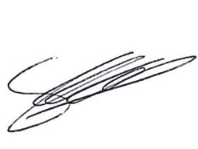
Signed Clerk of the Council Date: 3rd April 2024

AGENDA

Chair’s Welcome

Apologies for Absence and Reasons

Code of Conduct
Disclosable Pecuniary and other Interests.

Public Session

Minutes

Grants

Finance
Clerks Report

Exclusion of Press and Public

Staffing

Date of Next Meeting
Annual Council 13th May 2024

