NOTICE
The Town Council’s
Ordinary Council Meeting
to be held on
Thursday 4th January 2024

The Public and Press are cordially invited to attend.
To transact the business set out below.
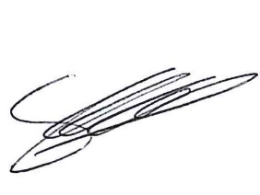
Signed Clerk of the Council

Date : 28th December 2023

AGENDA

Welcome

Apologies and the reasons for absence.

Public Session

Minutes from previous meeting

Borough Councillor Update

Grants

Finance

Finance- Budget setting for 2024/25

Clerks Report

Exclusion of Press and Public

