NOTICE
The Town Council’s
Executive Committee Meeting
to be held on
Thursday 16th November 2023

The Public and Press are cordially invited to attend.
To transact the business set out below.

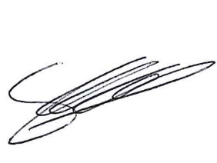
Signed Clerk of the Council Date: 10th November 2023

AGENDA

Chair’s Welcome

Apologies for Absence and Reasons

Code of Conduct

Public Session

Minutes

Grants

Finance
Finance returned AGAR

CAT Proposal

Community Governance Review

Budget 2024/ 25

Clerks Report

Exclusion of Press and Public

Staffing

Staffing
Staffing

Update 35 High Street

Partnership work Opportunity Telford & Wrekin Council

Community Allotments

December Exec Meeting

Date of Next Meeting
Full Council 15th January 2023
Exec 11th December 2023

