GREAT DAWLEY TOWN COUNCIL
 | Great Dawley Town Council  Town Hall  New Street  Dawley  TELFORD  TF4 3JR  Tel: (01952) 567 910  Fax: (01952) 567 917  e-mail: clerk@greatdawley.com
NOTICE
The Town Council’s
Executive Committee Meeting
to be held on
Monday 13th February 2023
Dawley Town Hall at 6.00pm

The Public and Press are cordially invited to attend.
To transact the business set out below.

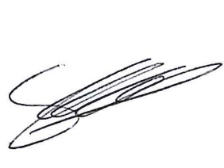
Signed: Chief Officer/ Clerk of the Council
Date: 8th February 2023

Chair’s Welcome

Apologies for Absence and Reasons

Code of Conduct

Public Session

Minutes

Borough Councillors

Grants

Finance
Armed Forces Covenant

Additional Christmas Lights

Gardening Service 2023

Clerks Report

Exclusion of Press and Public

STAFFING

Date of Next Meeting
Exec- 13th March 2023

