GREAT DAWLEY TOWN COUNCIL
 | Great Dawley Town Council  Town Hall  New Street  Dawley  TELFORD  TF4 3JR  Tel: (01952) 567 910  Fax: (01952) 567 917  e-mail: clerk@greatdawley.com
NOTICE
The Town Council’s
Executive Committee Meeting
to be held on
Monday 12th September 2022
Dawley Town Hall at 6.00pm

The Public and Press are cordially invited to attend.
To transact the business set out below.

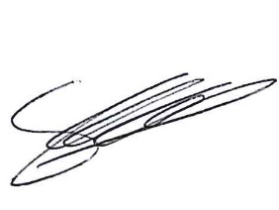
Signed: Chief Officer/ Clerk of the Council
Date: 6th September 2022

Chair’s Welcome
Apologies for Absence and Reasons
Code of Conduct
Public Session
Minutes
Borough Councillors
Grants
Finance
External Audit
Procurement Internal Audit
EVENTS
NALC Awards
Clerks Report
Exclusion of Press and Public
Staff
Dawley Park Play Area Upgrade
Christmas Office Hours
Correspondence

