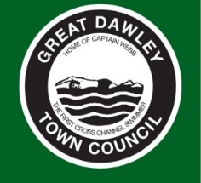
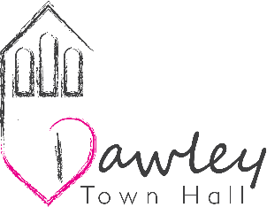

GREAT DAWLEY TOWN COUNCIL
VOLUNTEER ROLES

“Every Volunteer makes a Difference”

Volunteer Role | Dawley Town Hall Community Garden
Place of Volunteering Activity | Dawley Town Hall
Volunteering Days and Times | Times to suit you!
Volunteer Tasks and Responsibilities | - General maintenance of the garden including; weeding, sweeping, dead heading and cleaning of the green house  - Maintenance of tools; clean  - Liaise with staff members as Great Dawley for a plan of produce for the raised beds and hanging baskets  - Plant seasonal crops  - Water plants and produce  - Pick produce when ready  - Liaise with staff members at Great Dawley Town Council for the distribution of the produce
Desired Skills for the Role | - Good communication skills  - Work well within a team and on their own  - Use their own initiative  - A passion for gardening  - A knowledge of produce sowing
Training Great Dawley Town Council can offer for this Role | Great Dawley Town Council have a range of training opportunities that can be completed online:  - Manual Handling

Your Great Dawley Town Council contact will be:

Sarah Houlston
Project and Event Manager
01952 567910
07876401714
sarahh@greatdawley.com

