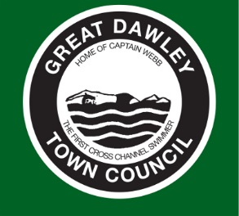

GREAT DAWLEY TOWN COUNCIL

The Local government Transparency Code 2014 requires that councils publish a list of land owned by the Council on an annual basis.

Unique Property Reference Number | Name of Building | Street Name & Number | Town | Postcode | Freehold or Leasehold | Map reference (Using Ordinance Survey Systems) | Land only or with permanent buildings
100071544132 | Dawley Town Hall | New Street, Dawley | Telford | TF4 3JR | Freehold | SJ685073 | With permanent buildings
000452066537 | Dawley House | 22 Burton Street, Dawley | Telford | TF4 2ES | Freehold | SJ682075 | With permanent buildings
000452071639 | The Hub | 3 & 4 New Street, Dawley | Telford | TF4 3JR | Freehold | SJ685073 | With permanent buildings
000452074176 | 35 High Street | 35 High Street, Dawley | Telford | TF4 2EX | Freehold | SJ684074 | With permanent buildings
010094518595 | Public Toilet | King Street, Dawley | Telford | TF4 2EX | Leasehold | SJ684074 | With permanent buildings

